What is difference between code program and Script?
- A Code can be defined as set of instructions which can be written in any form of a languages like java, Python, etc.
- A Program can be defined as set of instructions or code which is written to develop a software.
- A Script can be defined as set of instructions which are written are used for testing a Software.
As a developer whenever they build a software it means that developer has to give instructions to machine, machine based on those instructions (instructions will be in technical language) like java, .net, python.
Similarly, if a tester has to test a software it means that tester has to give or pass instructions to the machine.
Similarly, if a tester has to test a software it means that tester has to give or pass instructions to the machine
Core Jave → Stand alone
Advance java → Web applications
Hibernate → Enterprise applications
C, C++,Java

→ Problem → Solution

Every C/C++ program will have to go through 3 stage
- Writing: In the writing phase we will write the instructions in C/C++ language and after writing we need to save it. While saving we will give extensions like .c, .cpp
After saving these instructions will be given to the machine but these instructions is not understood by many machines because machine only understand binary language but these instructions which are written come under high level language. To provide solution we go to next stage
- Compilation:
In the compilation process the compiler will be responsible to convert high level language file (.c) → Low level language(.exe)

O/P
.exe
LLL
Binary
2.Compilation
.c → .exe
HLL →LLL
1.Writting
HLL
Save
.c/.cpp

Once compilation process is over you can go for execution.

3.Execution
- In the Execution process we make the exe file interact with the machine (double click)
- So once exe file interacts with machine it will pass instruction to machine on based on the instruction machine will perform instruction.
- In which ever platform we can perform execution.
- In which ever platform we combine only in that platform we can perform execution.
- In other platform we cannot execute.
- In other platform we cannot execute same file using C/C++ technology is know as platform dependent technology.

Core Java

Every java program should have to go through three stages
- WRITING:
Whenever we write a java program or instruction we have to save it .
While saving a java program it is mandatory that extension should be(.java).
Once we save java instructions these instructions should be given to the machine but java instruction by nature command a HLL but machine understands LLL.
- COMPILATION:
It is a process of converting HLL file to LLL.
In the compilation phase we had a compiler which is responsible to accept that input in .java format and when generate on output in .class format.
Regardless of whichever platform we compile we can generate a .class file.

- EXECUTION:
In the Execution process we make the exe file interact with the machine .
To execute a .class file java provides a special mechanism tool called as JVM (Java Virtual Machine).
But for JVM to perform execution it requires proper environment and that environment is provided my JRE (Java Runtime Environment)

3.Execution
.exe
LLL
Binary
2.Compilation
.java (HLL)
↓
.class (LLL)
1.Writing
HLL
↓
Save
↓
.java

Executable Binary Bytecode
What is the role of the compiler?
- The compiler is responsible to convert HLL to LLL
- The compiler checks if your code is written correctly or not. If there are mistakes, it shows errors.
- Once the .class file is generated we need to move to execution phase.
What is difference between JVM, JRE and JDK?
Provided at the bottom of pdf

There are three main editions of java:
- Core Java → Standard Edition → SE, JSE, J2SE
- Advance Java → Enterprise Editions → EE, JEE, J2EE
- Mobile/Macro → Mobile Edition → ME, JME, J2ME

JDK (Java Development Kit)
JDK is area where it includes or stores components like compiler, development tools, JRE and JVM.

JVM
Compiler
+ JRE
Libraries (Java Code)
+
Development tools
Skipped Installation, Verification
First Java Program
To write a java program there are two approaches
- Using Editors
- Using IDE (Integrated Development Environment)

EDITORS | IDE
- Notepad, Notepad++, Editplus  - We do not use in real time  - Editors do not help while coding  - 100% work done by developer/automation tester  - Editors by nature are slow  - If we use editors for learning we will become top developer or tester | - Ecllipse, IntellJ, Netbees, VsCode  - We use in real time  - They provide help  - 50% work done by IDE  - IDE’s are fast  - If we learn with IDE we will become average level developer and tester

Rules to create java program
- To write any instructions in java it should be written within class every class should have class name.
- Any instructions written within class should be written in curly braces.
- To enter within class it should have main method
- Any instruction written in main method it should be written in curly braces.
- To display message on java we use print statement
- To inform java it is end of statement we use semicolon
- Once we write java programs we need to save it while saving extension should be .java
Note: While saving a java program it is recommend as file name should be same as class name.
Compilation
- In the compilation stage a compiler will accept java file and it will generate .class file
- To perform compilation process we need to use command
Javac Demo.java
- To implement above command navigate to the .java file in editplus select the file right click on file and select cmd prompt, cmd from window will be displayed
- Whenever cursor is blinking type in the command.
Imp note: Whenever .class file is generated class file name will have same name as the class.

Execution
After the compilation is over we need to go for execution in the execution process we make class file interact with machine
This execution is possible with cmd called as class name and enter.

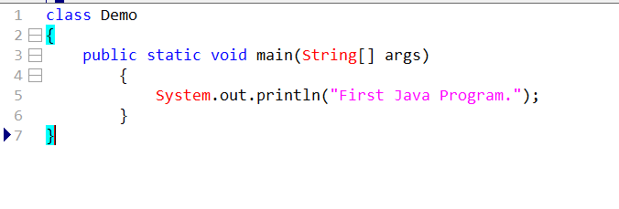
- Imp note: Java is a case sensitive language

In a java program we can write in one statement or we can write multiple statement
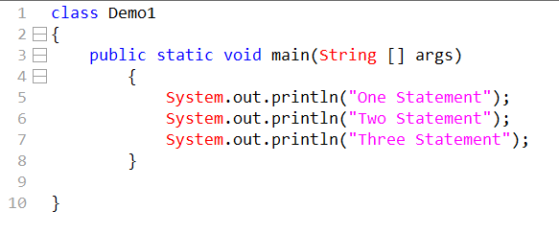
Demo1/Sample1

- The way print statement works is not it will print but it will also move java controller at the end

How do we print three statements in three lines
By using println statements we can move print statement in different lines The way println statement works not only it will print message but it also move java controller to next line.

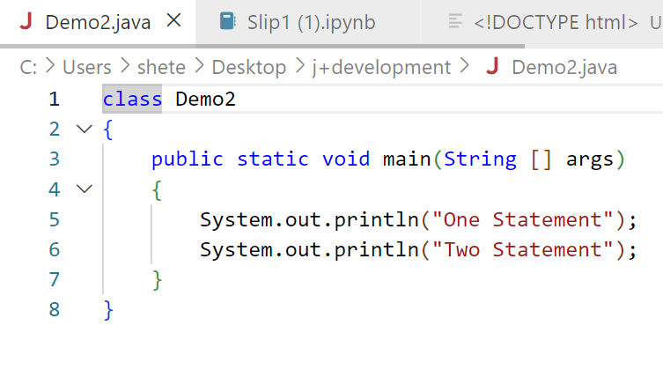Demo2 / Sample 2
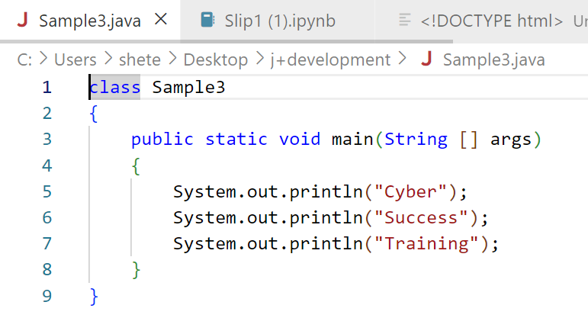
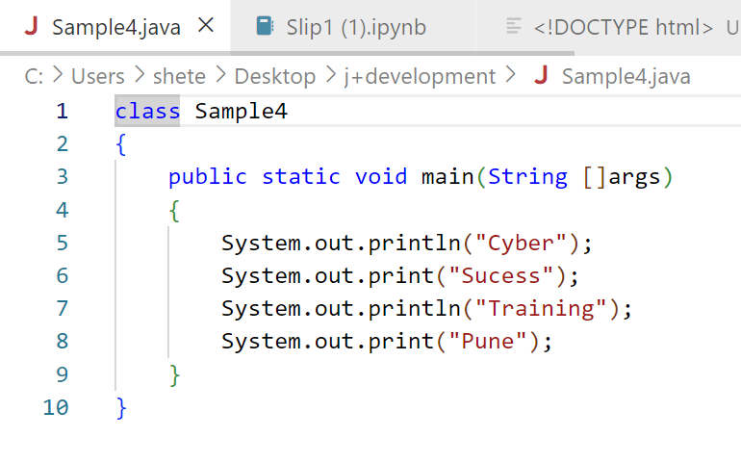

- It is not mandatory that the file name should be same as class name
If java file give different name apart form the class name will it perform compilation and execution.

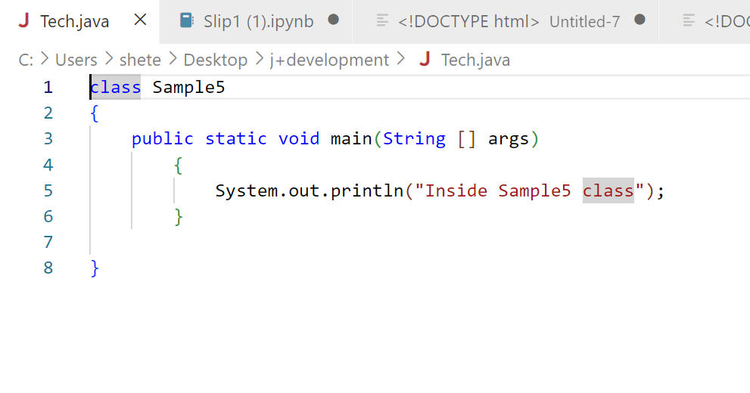
What is output of following code?
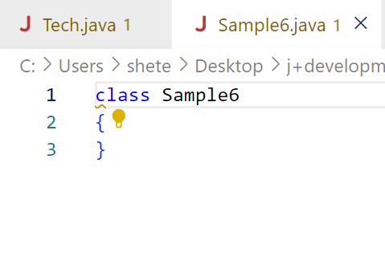
Observation:
- The above code will compile but will not execute
- The compiler does not depend on compilation process
- But JVM depend on main for execution process.

- In java program minimum we can create one class and maximum we can create multiple classes.

After compilation of java program how many ,class will created?
Depends on total number of classes present in java program that will generated .class file

Out of those class instead below which class will be get executed?
The class which contain main
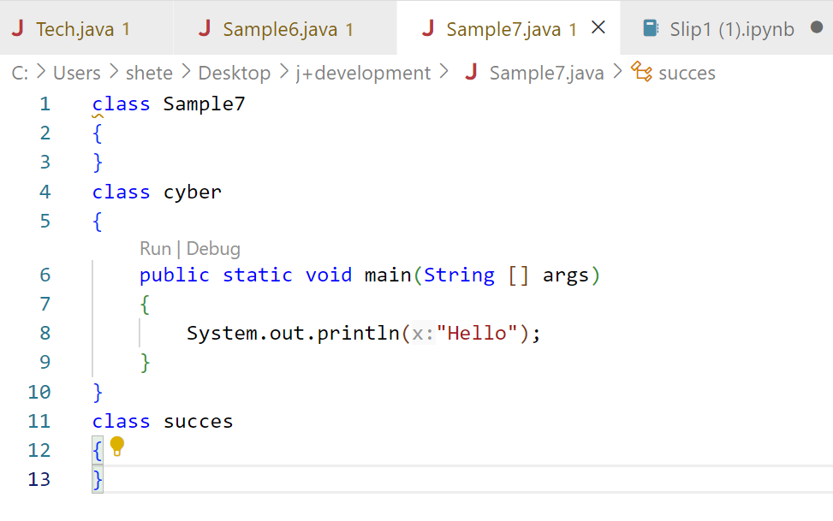
Can multiple main we use in multiple classes?
Yes

- Whenever we compile java program to compiler will compile all program at once shot
- But whenever we have to execute program it will only execute one class at time

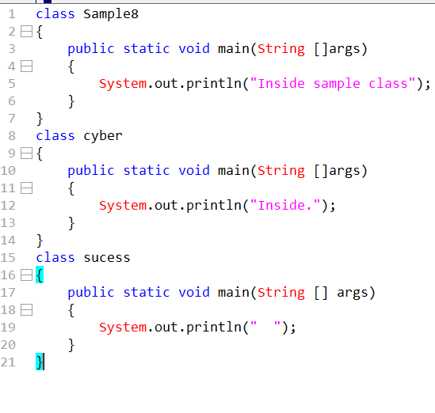
When is it manadatory the file should be save as class name?
Whenever class made is public mandatory the file name should be same as class name.
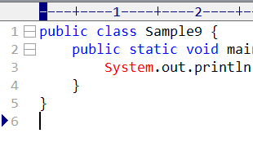
Observation:
- If program contain public class then we can also create other multiple classes
- If the class made public it does not need only class should contain main, main can be in any class

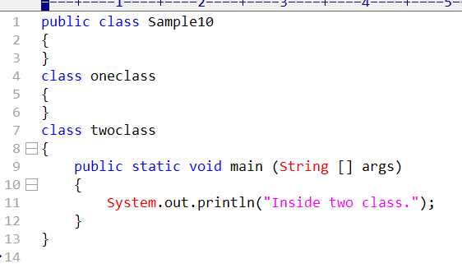
Is it possible to have or create two public class in java program?
It is not possible
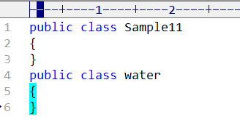
Observation:
Whenever there is any change in code it is mandatory that we have to recompiled the code and save or recompiled.

  - IMP Points
- The way print statement works it will not only print the statement but also moves the java controller at the end.
- In println statement it will print statement and also move controller to next line.
- It is not mandatory that file name should be same as class name unless class is declared with public access modifier.
- A Java program may contain multiple classes, but must contain at least one class.
- Empty class will compile but it will not execute.
- The compiler doesn’t depend on main for compilation process but the jvm depend on main for execution process.
- If a java program contains multiple classes, then the class with main method will execute.
- We can use multiple main methods in multiple classes but at the time of execution we can execute only one class at a time.
- If the class is made public it does not mean only that class should contain main, main can be in any class.
- It is not possible to create two public class in single java program.

- What is program?
Program is a set of instructions which are written in programming language to perform a specific task.

- Explain how does a program work?
Each program will have to go through three stages
- Writing: extension, programming language
- Compilation: HLL to LLL
- Execution: .exe, .class file interacts with machine,

3. What is role of the compiler?
- The compiler is responsible to convert HLL to LLL
- The compiler is also responsible while converting HL to LL whether the statements are correct or not.
- Once the .class file is generated we need to move to execution phase.

4. What is the difference between JVM, JRE and JDK?
- JVM (Java Virtual Machine):
Executes Java bytecode and provides platform independence. It handles memory management, garbage collection, and execution.
- JRE (Java Runtime Environment):
Provides the environment to run Java applications. It includes JVM + core libraries.
- JDK (Java Development Kit):
Used to develop and run Java applications. It includes JRE + development tools like javac, debugger, and compiler.
In short:
JDK → JRE → JVM (JDK contains JRE, JRE contains JVM).
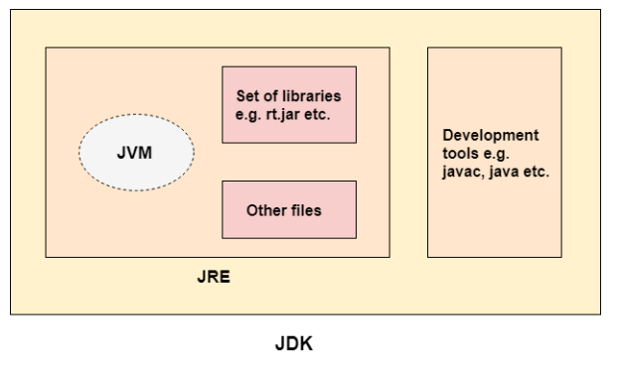

5. What are three main Editions of java?
- Core Java → Standard Edition → SE, JSE, J2SE
- Advance Java → Enterprise Editions → EE, JEE, J2EE
- Mobile/Macro → Mobile Edition → ME, JME, J2ME

6. What is difference between print and println statement?
•The way print statement works it will not only print the statement but also moves the java controller at the end.
•In println statement it will print statement and also move controller to next line.

7. Is it mandatory to keep file name and class name is same?
It is not mandatory that file name should be same as class name unless class is declared with public access modifier. But it considered as good coding practise worldwide.

8. How much classes should a java file contains
A Java program may contain multiple classes, but must contain at least one class.

9. What will happen if i try to execute empty class without main
If a java program contains multiple classes, then the class with main method will execute.

10. If a java file contains multiple classes which class will execute
If a java program contains multiple classes, then the class with main method will execute.

11. can we use multiple main methods
We can use multiple main methods in multiple classes but at the time of execution we can execute only one class at a time.

12. if the class is made public then is it mandatory to keep main method in it
If the class is made public it does not mean only that class should contain main, main can be in any class.

13. is it possible to create multiple public classes in single java file
It is not possible to create two public class in single java program.

14. What is Java?
Java is a popular high-level, object-oriented programming language that was originally developed by Sun Microsystems and released in 1995. Currently, Java is owned by Oracle, and more than 3 billion devices run Java. Java runs on a variety of platforms, such as Windows, Mac OS, and the various versions of UNIX. Today Java is being used to develop numerous types of software applications, including desktop apps, mobile apps, web apps, games, and much more

15. Why do we need programming Languages?
We humans communicate using native spoken language but machines do not understand our language they understand binary language or low-level language so in order to interact with machines we need programming language

16. What is Object oriented Programming?
Object-Oriented Programming is a way of writing programs by using objects, just like real-life things. Each object contains data and actions it can perform. This makes programs easy to understand, reuse, and manage.
For example, if I have bottle (entity in real life) then I will create class bottle and define its blueprint or parameter like size, colur, shape, price
So, convert real life entities into objects.

17.What are the features of java?
- Object Oriented: Java is an object-oriented language, and everything in Java is an object. Java supports OOPS principles like Inheritance, Encapsulation, Polymorphism, Classes, and so on. Java itself can be extended as well, being based on an object model.
- Platform Independent: Java code is platform independent. A Java code is not compiled into machine-specific code; it is compiled into a platform-neutral byte code. This byte code is executed by JVM which runs the code on the underlying platform. This capability makes Java a Write Once Run Anywhere language.
- Robust: Java is a very robust language with very strong compile-time error checks, strict type checking, and runtime exception handling
- Secure: Java is secure by architecture. A developer is not required to directly interact with the underlying memory or operating system. Java provides automatic garbage collection, so developers are not required to worry about memory leaks, management, etc.
- Multithreading: Java provides inbuilt support for multiprocessing and multithreading. Java provides thread handling, monitors, deadlock handling, racing conditions, etc.
- Architectural-Neutral: Java byte code can be executed on any kind of processor. JRE automatically handles the code execution on different types of processors.
- Portable: A Java code written on a Windows machine can be executed without any code change on MacOS and vice versa. There is no need to make any operating system-specific code changes.
- High Performance: Java, although being interpreted, is still very performant. The JIT (Just In Time) compiler helps in improving performance.
- Distributed: Java is designed for distributed systems and is the most popular language for developing internet-based applications as the internet is a distributed environment.
- Easy To Learn: Java inherits features from C and C++, and developers can easily learn Java if they know any of the C or C++ languages. Even for someone new to computer languages, Java is very easy to learn from scratch.

18. How java is platform Independent and Robust?
- Java code is platform independent. A Java code is not compiled into machine-specific code; it is compiled into a platform-neutral byte code. This byte code is executed by JVM which runs the code on the underlying platform. This capability makes Java a Write Once Run Anywhere language.
- Java code is compiled as well as Interpreted so it provides strict error checking and because of that there is very less chance of system failure. Java is a very robust language with very strong compile-time error checks, strict type checking, and runtime exception handling.

19. What is JIT Compiler?
Answer (Short):
JIT (Just-In-Time) compiler improves Java performance by converting bytecode into native machine code at runtime.

20. What is bytecode?
Answer:
Bytecode is an intermediate code generated by the Java compiler (.class file) which is executed by the JVM.

21. What is class and object? With examples
Answer:
- Class: Blueprint of an object
- Object: Instance of a class
Example 1: Car
Class: Car (blueprint)
Properties: color, brand, speed
Methods: start(), drive(), stop()
Objects: car1 (Red BMW), car2 (Black Audi)
Example 2: Bank Account
Class: BankAccount (blueprint)
Properties: accountNumber, holderName, balance
Methods: deposit(), withdraw(), checkBalance()
Objects: acc1 (Rushi), acc2 (Amit)

22. What is main method in Java?
Answer:
The main() method is the entry point of Java program execution.

23. Why main method is static?
Answer:
So JVM can call it without creating an object.

24. Why is Java not 100% object-oriented?
Answer:
Because Java uses primitive data types like int, float, char, etc.

25. What is Garbage Collection?
Answer:
It is process of removing unused objects performed by JVM, It improves perfomance and prevents memory leaks.

26. What is Stack and Heap?
Answer:
Stack memory is used for method execution and storing local variables, while heap memory is used for dynamic memory allocation where objects are stored and managed by garbage collection.

  - SOME EXTRA POINTS

Class Loader
Classloader is a subsystem of JVM which is used to load class files. Whenever we run the java program, it is loaded first by the classloader. There are three built-in classloaders in Java.
- Bootstrap ClassLoader: This is the first classloader which is the super class of Extension classloader. It loads the rt.jar file which contains all class files of Java Standard Edition like java.lang package classes, java.net package classes, java.util package classes, java.io package classes, java.sql package classes etc.
- Extension ClassLoader: This is the child classloader of Bootstrap and parent classloader of System classloader. It loades the jar files located inside $JAVA_HOME/jre/lib/ext directory.
- System/Application ClassLoader: This is the child classloader of Extension classloader. It loads the classfiles from classpath. By default, classpath is set to current directory. You can change the classpath using "-cp" or "-classpath" switch. It is also known as Application classloader.

Class (Method Area)
Class(Method) Area stores per-class structures such as the runtime constant pool, field and method data, the code for methods.

Heap
It is the runtime data area in which objects are allocated.

Stack
Java Stack stores frames. It holds local variables and partial results, and plays a part in method invocation and return. Each thread has a private JVM stack, created at the same time as thread. A new frame is created each time a method is invoked. A frame is destroyed when its method invocation completes

Program Counter Register
PC (program counter) register contains the address of the Java virtual machine instruction currently being executed. Native Method Stack

Execution Engine
It contains all the native methods used in the application.

Java Native Interface
It contains:
1. A virtual processor
2. Interpreter: Read bytecode stream then execute the instructions.
3. Just-In-Time(JIT) compiler: It is used to improve the performance. JIT compiles parts of the byte code
that have similar functionality at the same time, and hence reduces the amount of time needed for
compilation. Here, the term "compiler" refers to a tran

Java Native Interface
Java Native Interface (JNI) is a framework which provides an interface to communicate with another application written in another language like C, C++, Assembly etc. Java uses JNI framework to send output to the Console or interact with OS libraries.

